**CS 550 PROJECT 1**

Name: CHI CHIEH WENG

Email: wengchic@oregonstate.edu

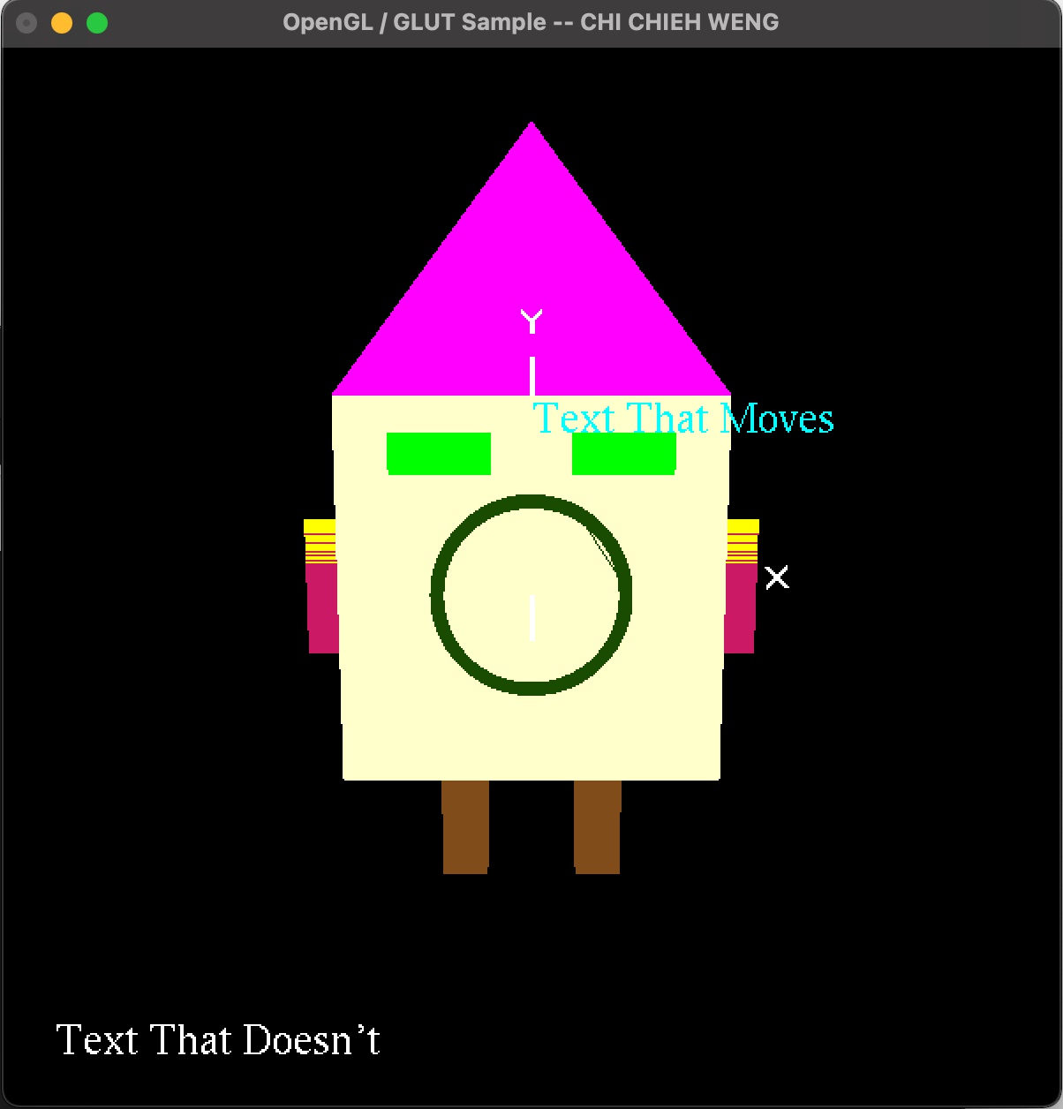

Video lnik: https://media.oregonstate.edu/media/t/1_yktkjan6